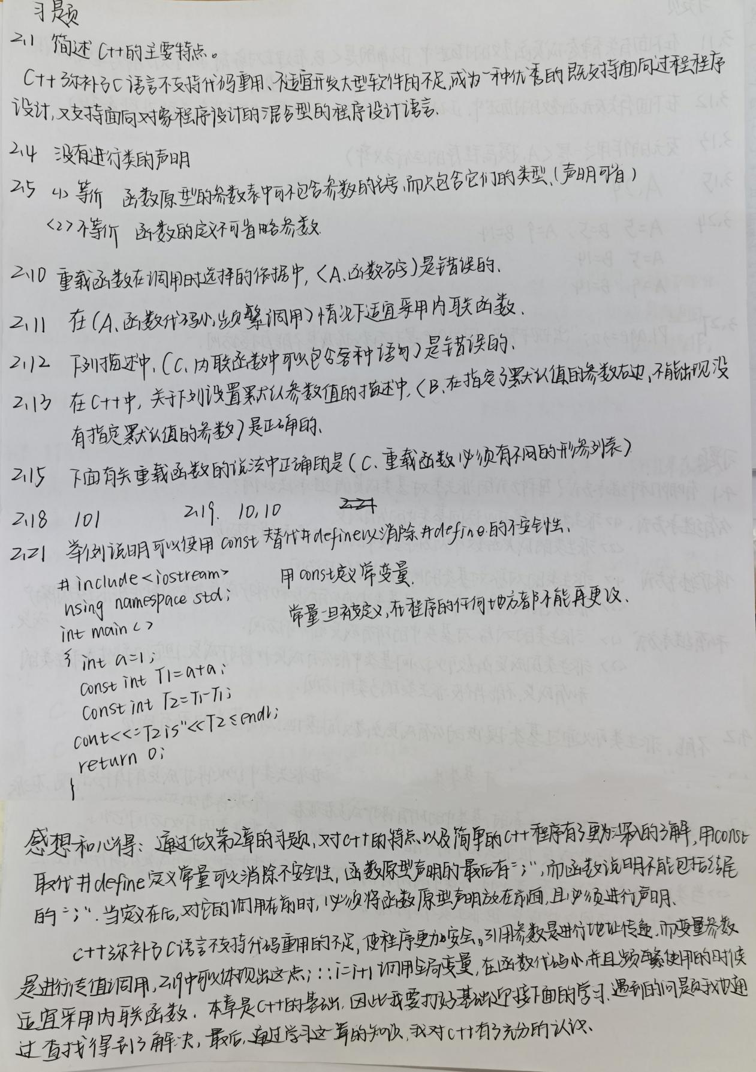

Copyright ©2021-2099 HuixinLi. All rights reserved